Gen_Name:Name=BST2;
Entry_name:BST2_HUMAN
Seq_length:180
OrganismClass:['Eukaryota', 'Metazoa', 'Chordata', 'Craniata', 'Vertebrata', 'Euteleostomi', 'Mammalia', 'Eutheria', 'Euarchontoglires', 'Primates', 'Haplorrhini', 'Catarrhini', 'Hominidae', 'Homo']
Organism:'Homo sapiens (Human).'
Taxonomy:['9606']
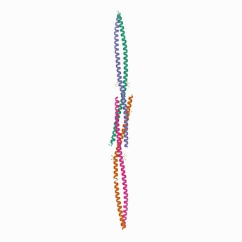
Function:FUNCTION: IFN-induced antiviral host restriction factor which efficiently blocks the release of diverse mammalian enveloped viruses by directly tethering nascent virions to the membranes of infected cells. Acts as a direct physical tether, holding virions to the cell membrane and linking virions to each other. The tethered virions can be internalized by endocytosis and subsequently degraded or they can remain on the cell surface. In either case, their spread as cell-free virions is restricted. Its target viruses belong to diverse families, including retroviridae: human immunodeficiency virus type 1 (HIV-1), human immunodeficiency virus type 2 (HIV-2), simian immunodeficiency viruses (SIVs), equine infectious anemia virus (EIAV), feline immunodeficiency virus (FIV), prototype foamy virus (PFV), Mason-Pfizer monkey virus (MPMV), human T- cell leukemia virus type 1 (HTLV-1), Rous sarcoma virus (RSV) and murine leukemia virus (MLV), flavivirideae: hepatitis C virus (HCV), filoviridae: ebola virus (EBOV) and marburg virus (MARV), arenaviridae: lassa virus (LASV) and machupo virus (MACV), herpesviridae: kaposis sarcoma-associated herpesvirus (KSHV), rhabdoviridae: vesicular stomatitis virus (VSV), orthomyxoviridae: influenza A virus, paramyxoviridae: nipah virus, and coronaviridae: SARS-CoV. Can inhibit cell surface proteolytic activity of MMP14 causing decreased activation of MMP15 which results in inhibition of cell growth and migration. Can stimulate signaling by LILRA4/ILT7 and consequently provide negative feedback to the production of IFN by plasmacytoid dendritic cells in response to viral infection. Plays a role in the organization of the subapical actin cytoskeleton in polarized epithelial cells. Isoform 1 and isoform 2 are both effective viral restriction factors but have differing antiviral and signaling activities. Isoform 2 is resistant to HIV-1 Vpu-mediated degradation and restricts HIV-1 viral budding in the presence of Vpu. Isoform 1 acts as an activator of NF-kappa-B and this activity is inhibited by isoform 2.

Crystal structure of BST2/Tetherin.

Através do software LocTree3 verificamos a localização da proteína em estudo, neste caso localiza-se na membrana plasmática.
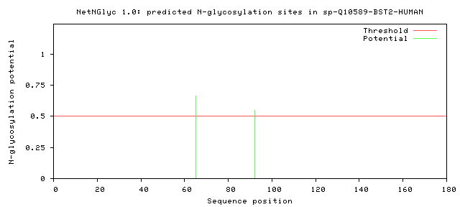
Através do software NetNGlyc, verifica-se que acontecem 2 glicolisações.

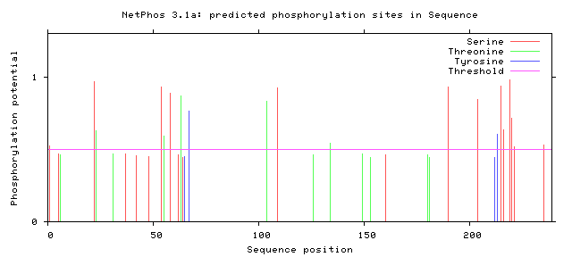
Através do software NetPhos, é possível verificar os locais de fosforilação da proteína em estudo.

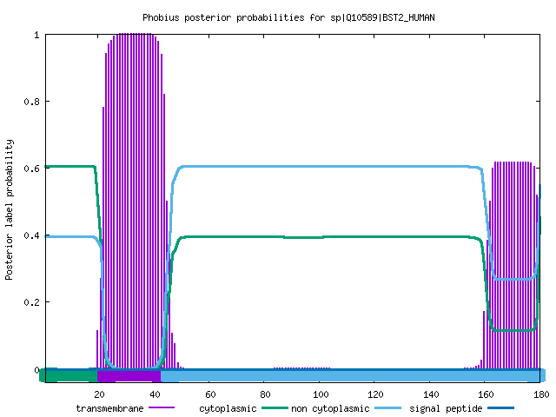

Através do software Phobius, é possível verificar os domínios existentes na proteína em estudo. Verifica-se um domínio transmembranar.

